Module Name : Login Module
Application/Software : Google Chrome Web Browser
SDLC Model :Waterfall Model

1. TESTING PROCEDURE
Step1.:
- Open the Website
- Open Google Chrome.
- Open the Practice Automation Testing Website.
- Navigate to the Test Login Page.
- Verify that the login page is displayed.
Screenshots:
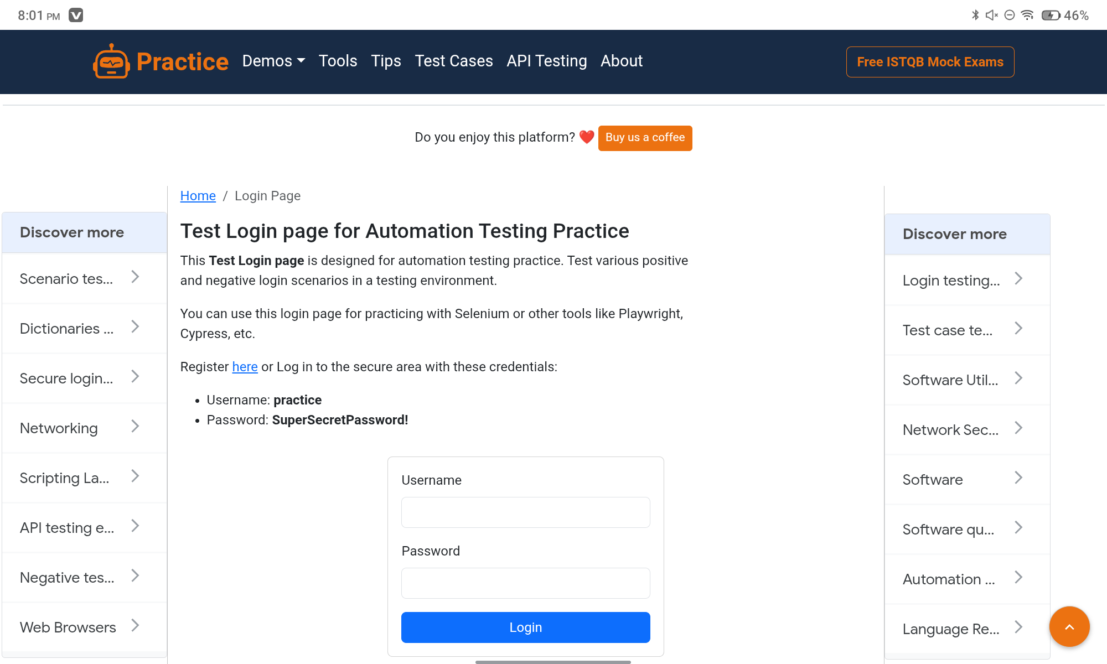
Steps 2:
- Enter Username
- Locate the Username field.
- Enter the valid username: practice
- Verify that the username is accepted.
Screenshots:
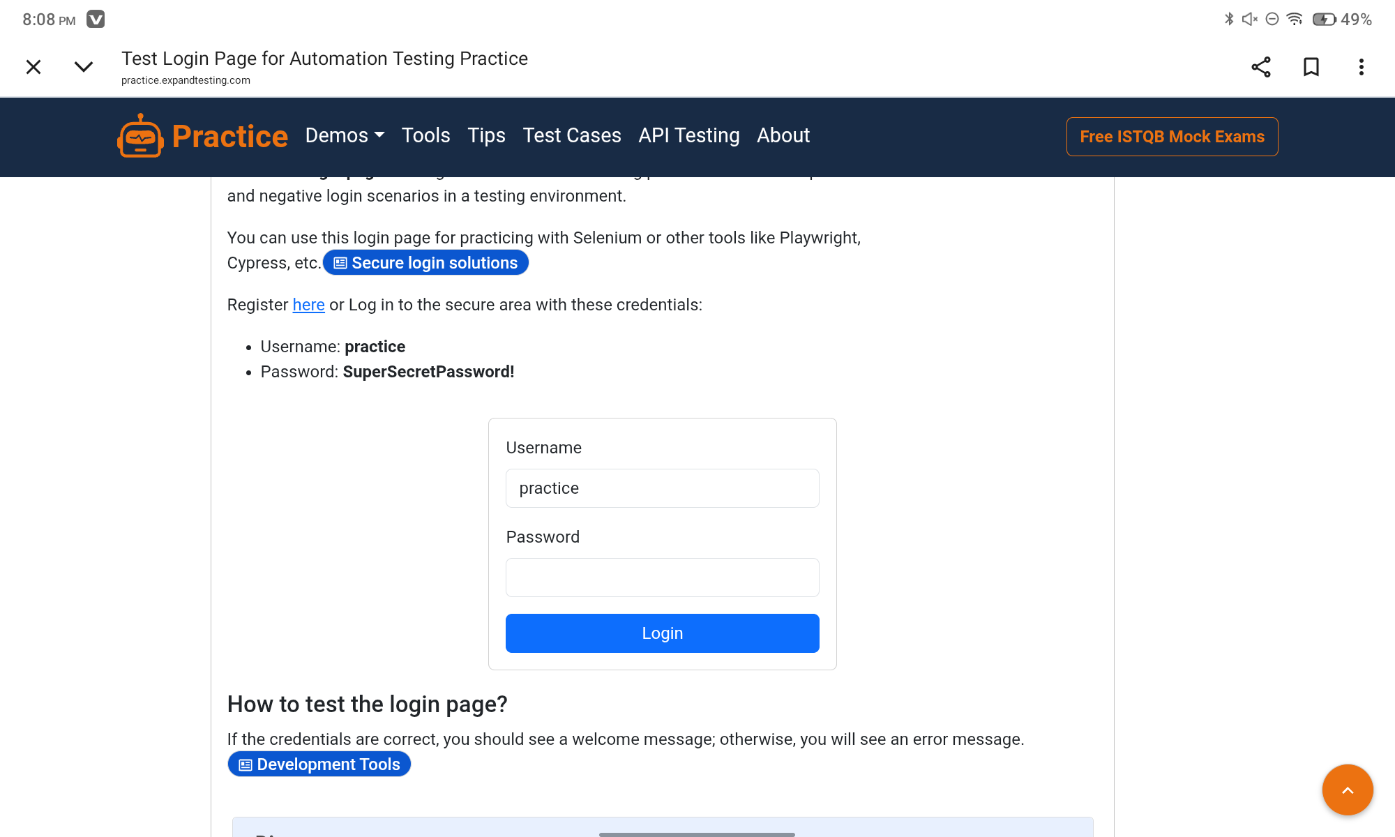
Step 3:
- Enter Password
- Locate the Password field.
- Enter the valid test password: SuperSecretPassword!
- Verify that the password is entered correctly.
Screenshot:
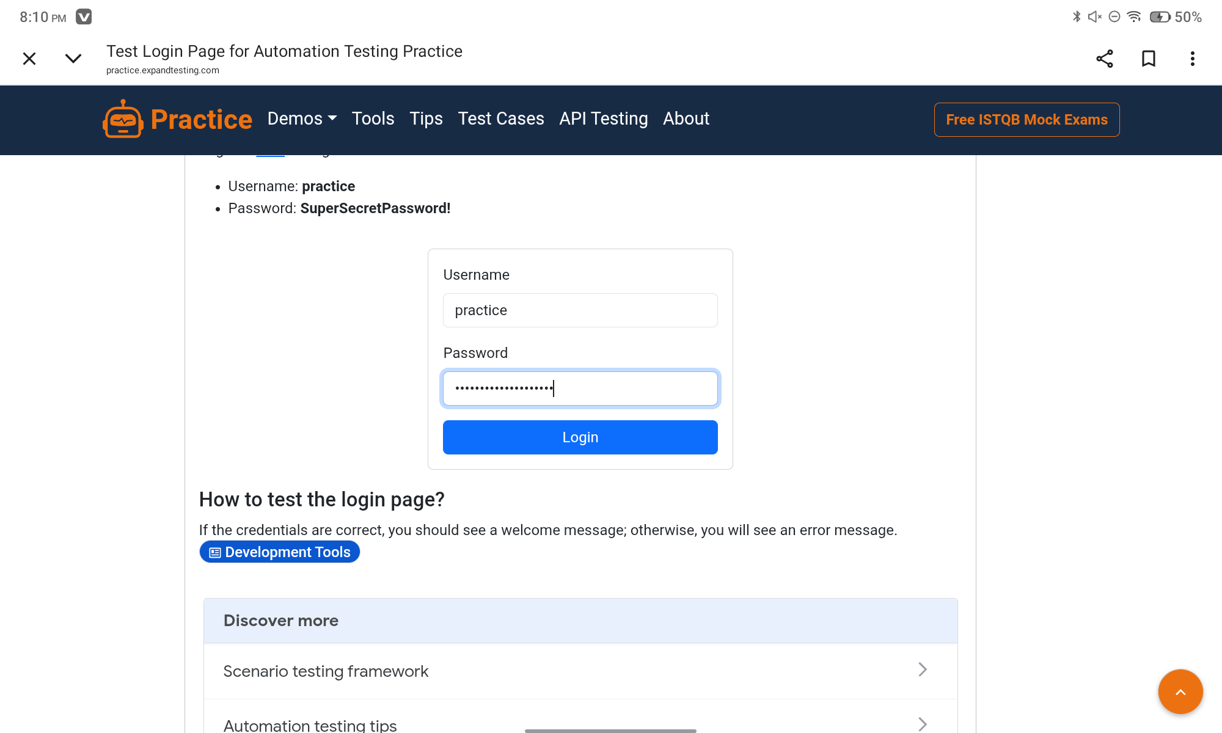
Step 4:
- Click the Login button.
- Wait for the page to load.
- Observe the result after submitting the credentials.
Screenshot:
